Agile Express

High Level Design Document
Date: August 2025
Project: OBSS 2025 Summer Internship

1. Project Overview
Agile Express is a simplified agile project management system designed for software development teams to manage projects using agile methodologies.

1.1 Core Capabilities
- Multi-project management with team structures
- Sprint planning and execution with backlog management
- Task tracking with Kanban boards
- Role-based access control and security
- Real-time progress monitoring and analytics

1.2 Target Users
Software development teams of all sizes, from startups to enterprise organizations adopting agile methodologies.

2. System Overview
User Roles: Admin, Project Manager, Team Lead, Team Member (each with specific permissions).
Authentication: Login via LDAP and Google accounts.
Dashboard: Role-based project and task view/edit capabilities.
Project Management: Create projects, assign roles, set start/end dates, define statuses.
Sprint Management: Create and manage sprints, move tasks from backlog to sprint, assign tasks, set story points and estimated times.
Task Management: Create/edit tasks, assign users, update status, log work time.
Search: Search projects, tasks, and people across all related records with role-based access.
Extra Features: Sprint end reminders via email, burndown charts, and other optional enhancements.

3. Architecture Decisions
- Pattern: Full-stack layered architecture — Spring Boot REST API (backend) + Next.js React with TypeScript (frontend) + relational DB via JPA/Hibernate.
- Backend: Monolithic for simplicity, structured with Controller → Service → Repository layers. Uses JWT authentication with LDAP and Google OAuth2. Implements RBAC with four roles. Entities modelled with clear relationships, lazy loading, and cascade rules.
- Frontend: Next.js App Router with reusable components, TypeScript, and React Query for server state (caching, optimistic updates, smart invalidation). Uses hooks for API calls and keeps client state minimal.
- Security: Hybrid JWT + LDAP authentication, OAuth2 support, role-based method security, and input validation.
- Design Choices: Monolith now but microservice-ready; domain-driven boundaries for Project, Sprint, Issue, User; normalized DB schema; strong logging and error handling.

4. Logical Design Diagram
See “logical design diagram.png”
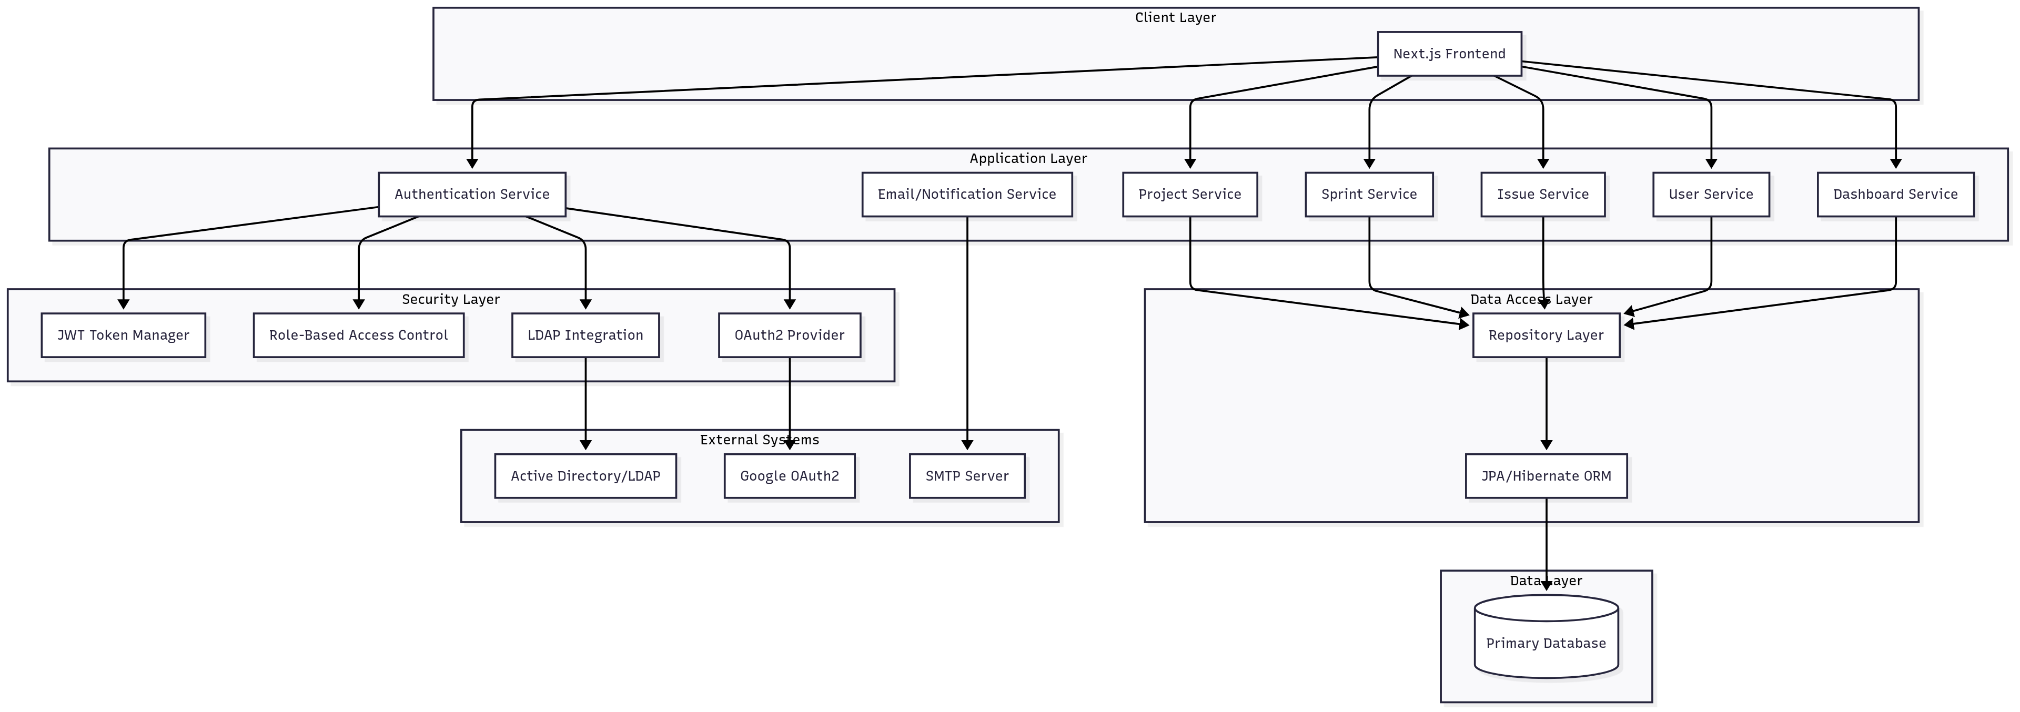

5. Physical Deployment Diagram
See “deployment diagram.png”
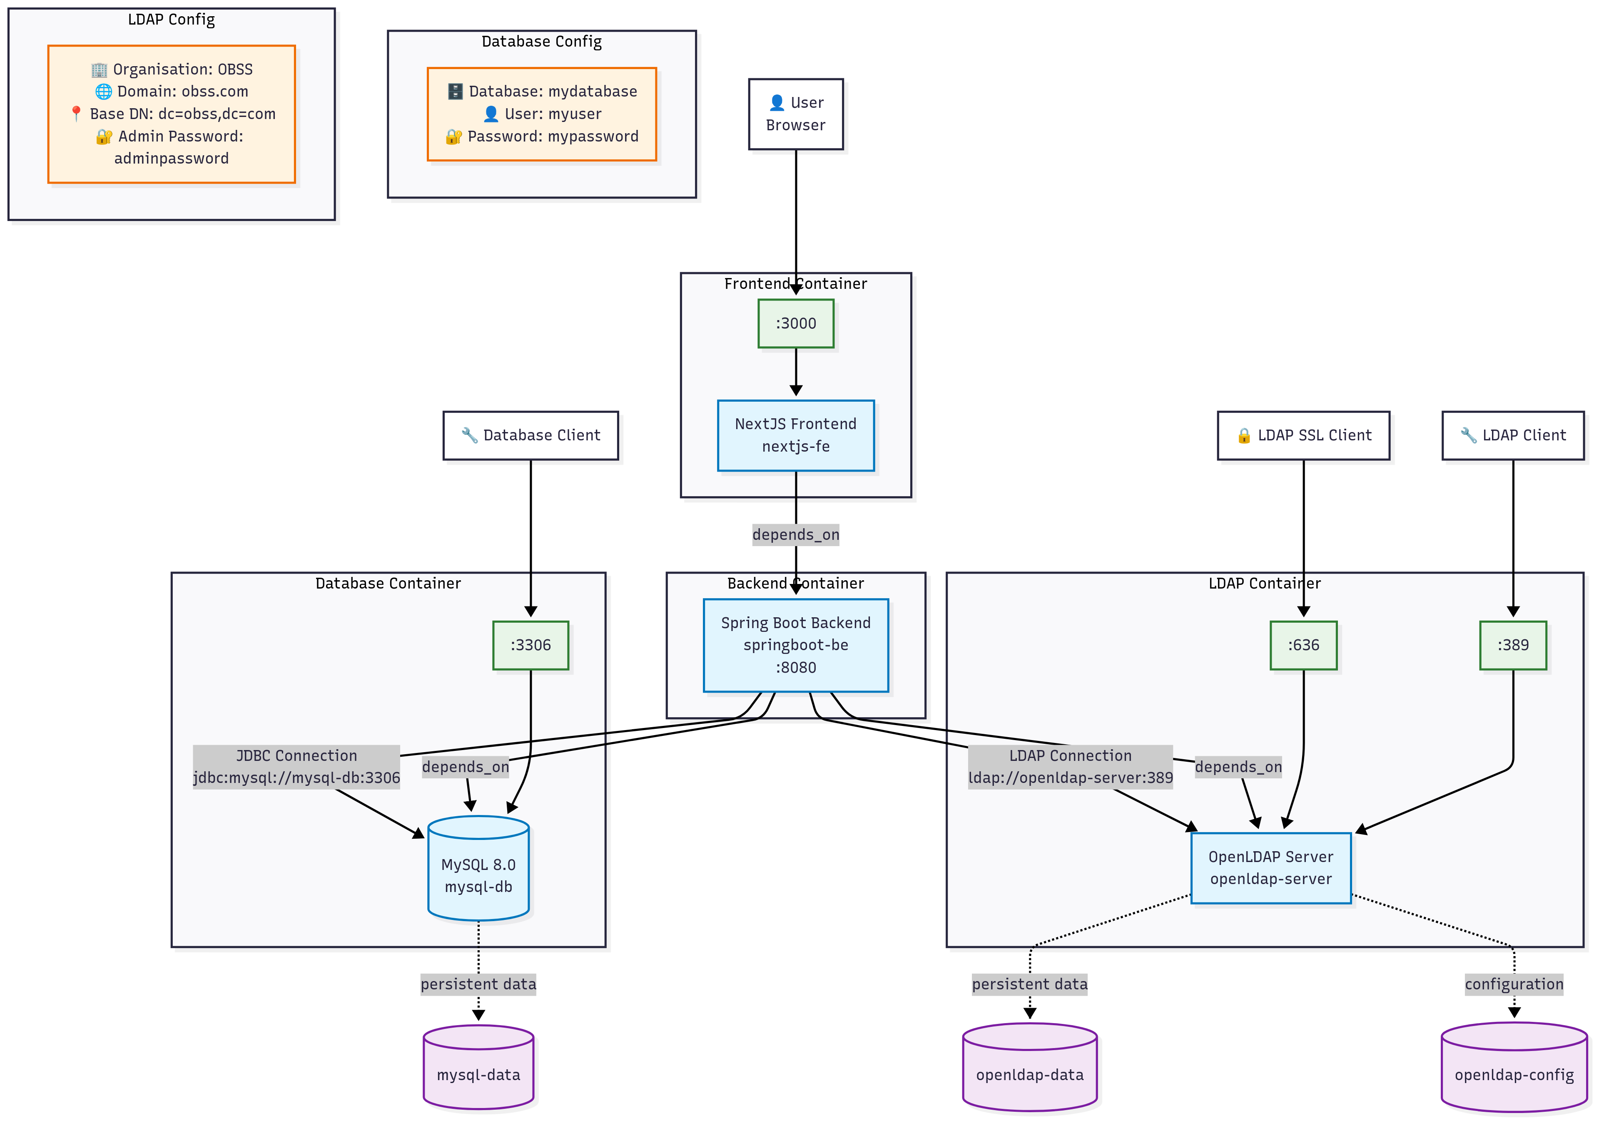

6. Technology Stack

Backend Technologies
Component | Technology | Version

Framework | Java + Spring Boot | 17 + 3.x
Security | Spring Security | 6.x
Authentication | JWT, OAuth2, LDAP | -
Data Access | Spring Data JPA | -
ORM | Hibernate | -
Build Tool | Maven | -

Frontend Technologies
Component | Technology | Version
Framework | Next.js + React | 14 + 18
Language | TypeScript | 5.x
Styling | Tailwind CSS | 3.x
State Management | TanStack Query | 5.x
HTTP Client | Axios | 1.x
Charts | Chart.js | 4.x

Database & Infrastructure
Component | Technology
Database | MySQL
ORM | JPA/Hibernate
Deployment | Docker Compose

7. Database ER Diagram

